DEPARTMENT OF PHARMACEUTICAL CHEMISTRY

TOPIC: INNOVATES DRUG IN DISCOVERY AND DEVELOPMENT FROM INNATE RESOURCES-CHALLENGES AND OPPORTUNITIES.

DATE: DECEMBER 2017

TYPE: TWO DAYS CEP PROGRAM

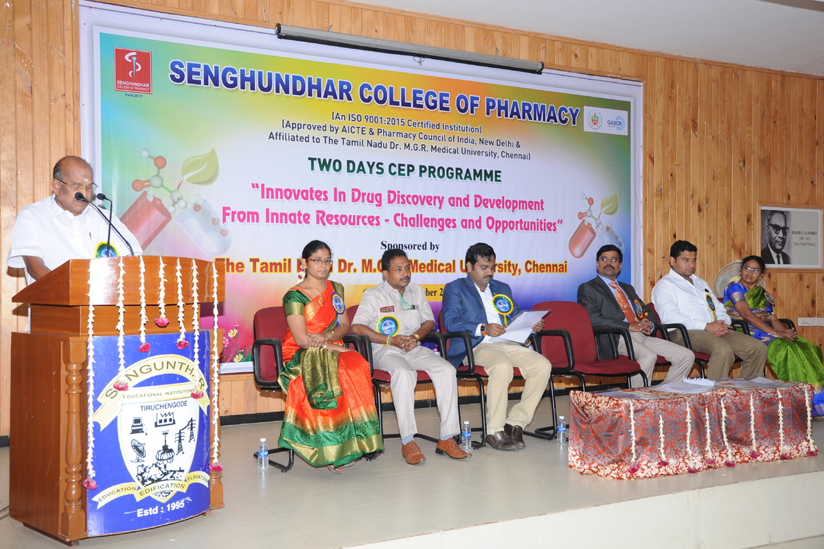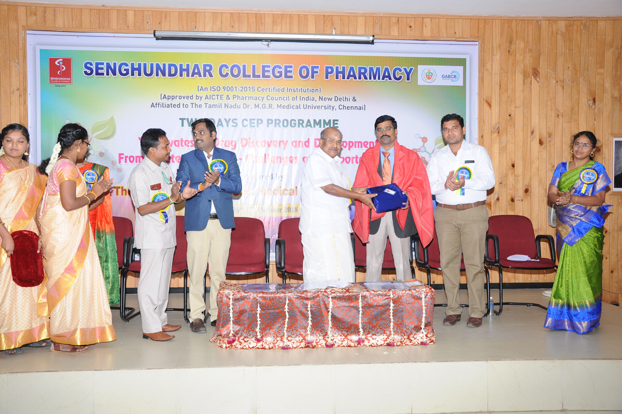

DEPARTMENT OF PHARMACEUTICS

TOPIC: CURRENT TRENDS AND FUTURE PERSPECTIVE OF DRUG DELIVERY SYSTEMS”

DATE: 9 TH AND 10 TH OF DECEMBER-2022

TYPE: TWO DAYS INTERNATIONAL CONFERENCE

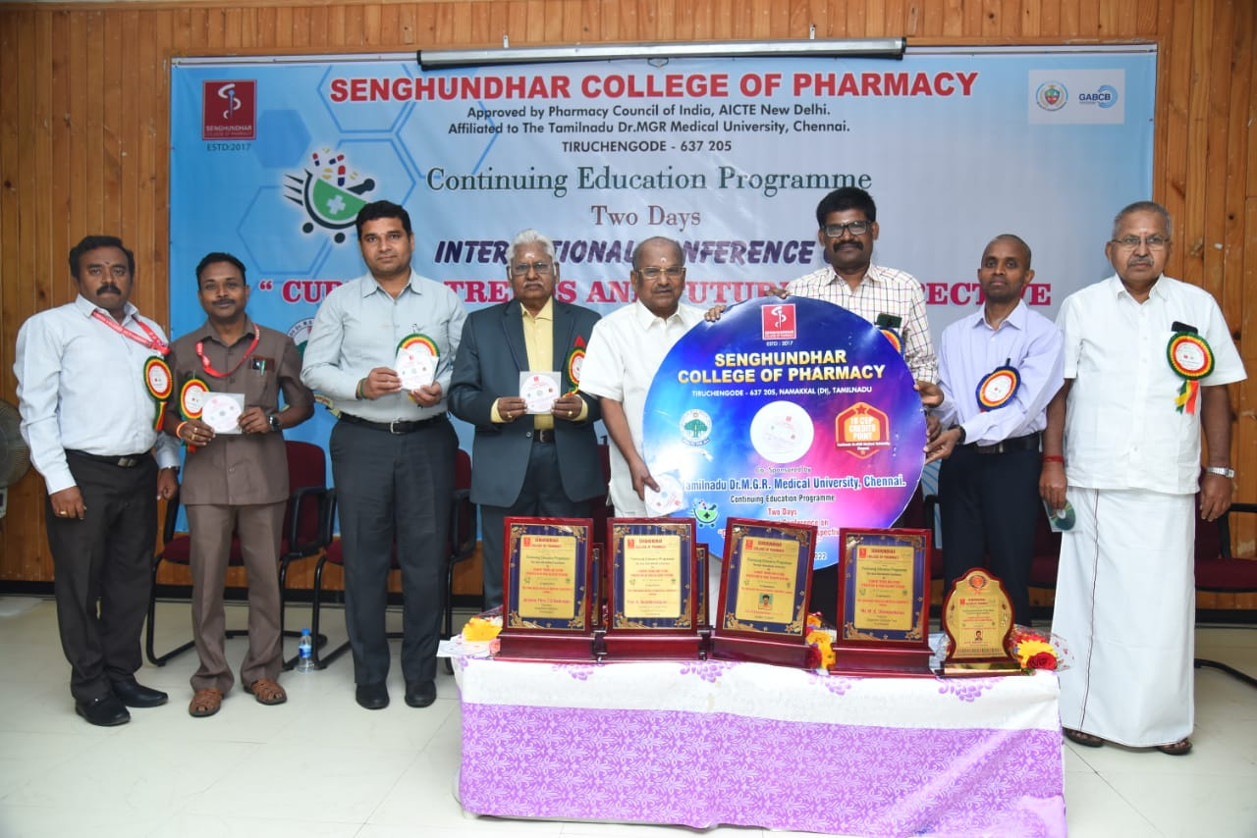

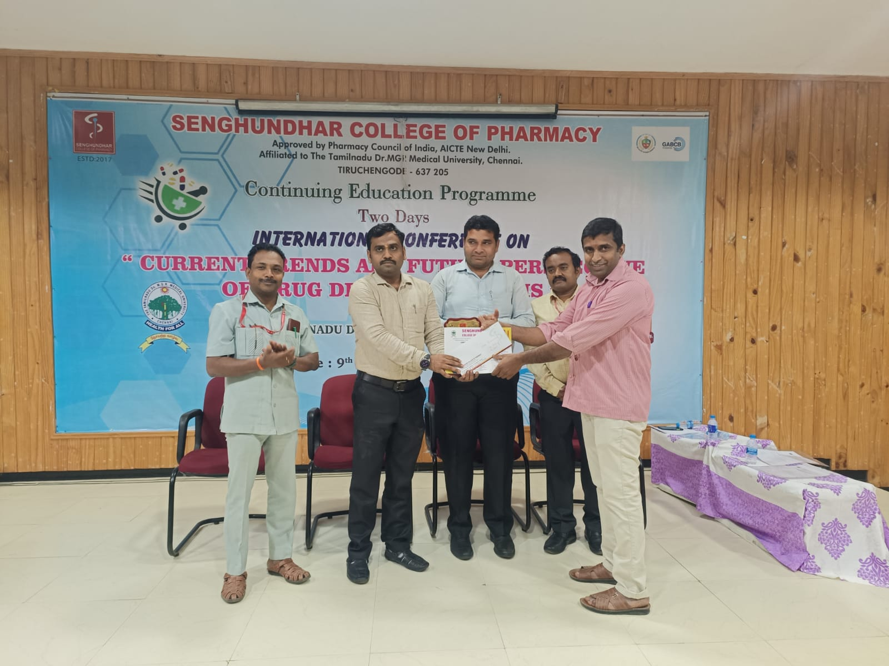

DEPARTMENT OF PHARMACOLOGY

TOPIC: THE PRECLINICAL RESEARCH PARADIGM FOR REVEMPED INFECTIOUS DISEASES”

DATE: 27TH AND 28 TH OF JULY-2023

TYPE: TWO DAYS INTERNATIONAL CONFERENCE

